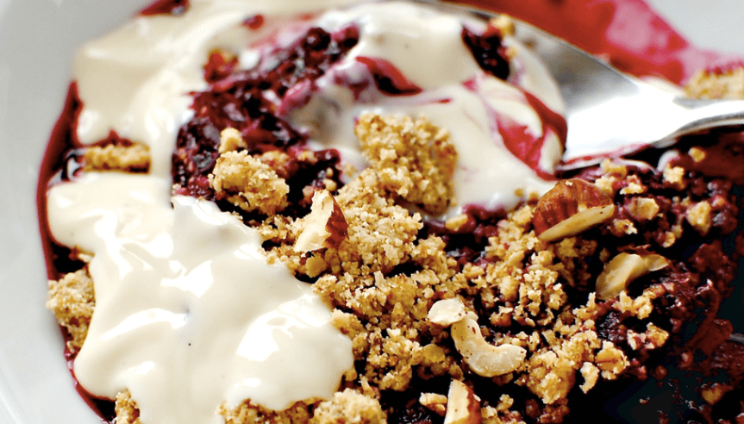

Fruit Crumble
This recipe is ideal as you can use any fruit you like! Apple, pear, peaches, blackberries, banana, the choice is yours. We’ve made an apple crumble, but what you decide to make is up to you!
Ingredients
4 large apples (or fruit of your choice)
30g white flour
30g wholemeal flour
30g margarine
15g sugar
Method
1. Peel and core the apples, place in an ovenproof dish and sprinkle with a little sugar.
For the topping:
2. Rub together 30g white flour, 30g wholemeal flour, 30g of margarine and 15g of sugar. The mixture should have a crumbly texture.
3. Spread over the fruit & bake for 20 minutes at 180°C/Gas Mark 4.

