Allotments – Week 1 learning activities.
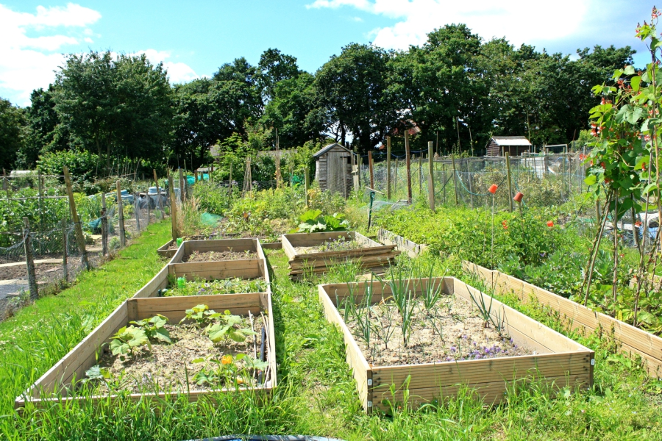
If you are able visit a local allotment site, or a garden go and see if there are any fruit and vegetables growing. Take photographs, draw pictures and ask questions of those people you know who enjoy gardening. You could phone or FaceTime a family member or friend who likes to grow their own fruit and veg. Perhaps you can join in with some digging, weeding, planting and harvesting! Take samples of food grown in your garden or allotment to taste and enjoy. NB - If are able to go out please do make sure that social distancing is observed at all times.
The learning intention for this term is to use spoken language to extend knowledge using question words, “who what when where why how?”
If you are not able to access a garden or allotment here is a video clip watch and talk about with your family.
Top tips for new allotment holders
https://www.youtube.com/watch?v=ToyvxcLP14Q
Allotment eBook – A book to share with an adult.
https://www.twinkl.co.uk/go/resource/tg2-t-42-go-teach-allotments-ebook

Sensory learning activities
Go outside for a learning walk, name the fruit and vegetables that you find growing in the garden. Collect sticks, leaves and anything interesting (an adult will need to support this to make sure that it is safe to collect these items)
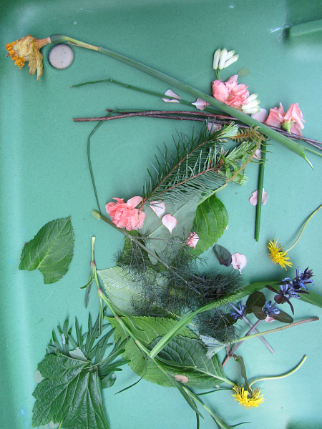
Look for structures, like a green house, shed, frames for plants etc. Draw what you see, or use a crayon to make rubbings of different textures. Label your drawings or ask an adult to help you.
Make a nature collage
You will need a large piece of paper and some glue.
Talk about what you have found – ask and answer questions. You could use your leaves and twigs to make a garden scene, get creative and have fun!
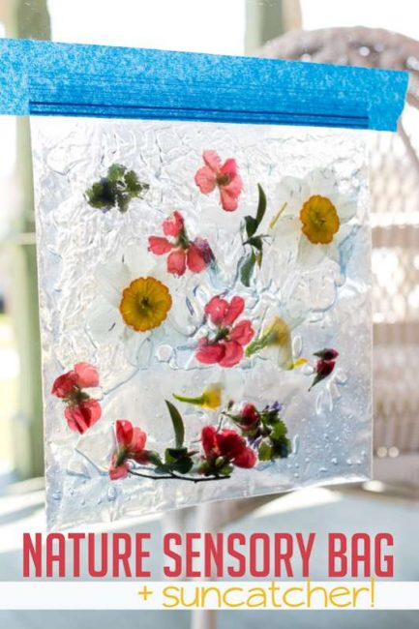
Make a nature sensory bag
Fill a clear bag with hair gel and add the items that you find on your learning walk. The bag can be taped to a window to investigate, squeeze and squish, so that you can explore the different objects and see the colours.

Webpages to explore with your family
The National Allotment Society
https://www.nsalg.org.uk/resources-and-downloads/individuals-and-schools/
Learning through landscapes
https://www.ltl.org.uk/
Outdoor learning ideas
https://www.ltl.org.uk/free-resources/

