The Frog Olympics
LO – to know the story of The Frog Olympics
I can:
- Read the story.
- Answer literal, inference and deduction questions about the story.

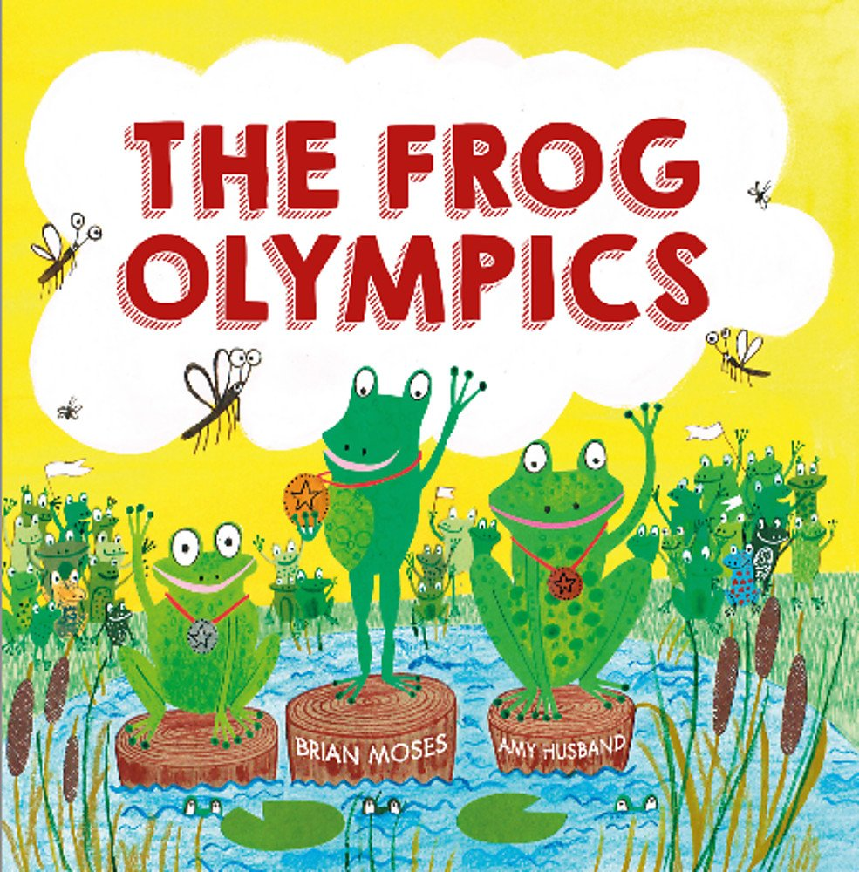

Comments:

