Week 5 beginning 29.06.20 PE Willow Class
As we are not able to hold Sports Day this Term we decided each week we could practise technique and then perform each activity.
Throwing: Throwing games for accuracy and distance
To throw accurately and far

W/up: throw and catch with a partner 1. How many 2. On one leg 3. Backwards 4. Between your knees.

M/Activity: If you have an outdoor space this is ideal, however you can do this indoors
Alternative session: Perform the activity at a slower pace. Use objects to collect along a straight line and return them.
Equipment: Tape measure, markers, score sheet, objects to throw – socks, balls, bean bag, toys, paper rolled into a ball with Sellotape, hoop/dustbin/marked area.
- See if you can get your object into the target throwing underarm. When you have achieved this 3 times take a step back – how far back can you go?
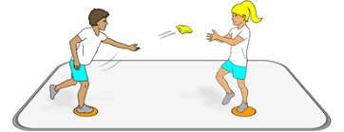
- Balance on one leg and repeat
- Throw backwards over your head
- Try overarm and see if you can get further
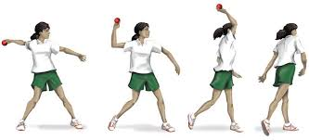
- Have a throw and see how far you can throw – get someone to record this. Look at the pictures above and practise throwing like this, then measure three throws and see if you get any further.
You can record your distance and send it to Mr Gardner on the school email and so that we can collate the results and let you know how you did.

Alternative Session :
w/up –Sherborne
Greeting: Clap hands, tap knees, stomp feet, call name.
Self – Squeeze Shoulders, run hands and rub hands and wiggle fingers and then, pulling on each finger. Move hands from side to side slowly and then wave. windscreen wiper feet, in and out feet, pointy toes, naughty toes.
Core – legs in the air, arms in the air, both in the air, rock, spin. Go on hands and knees, crawl or put pressure on hands and knees.
Share: back to back – side to side, forward and backward. Facing – row your boat, on knees and push against each other.
Heads, shoulders knees and toes.

