Going to a Cafe for Lunch
Put a tick in the correct box Put tick boxes next to each answer
- What time is the cafe open on a Friday?
  - 8 a.m. – 3:30 p.m.
  - It is closed
  - 7:30 a.m. – 4 p.m.
- What flavour is the soup of the day?
  - Tomato
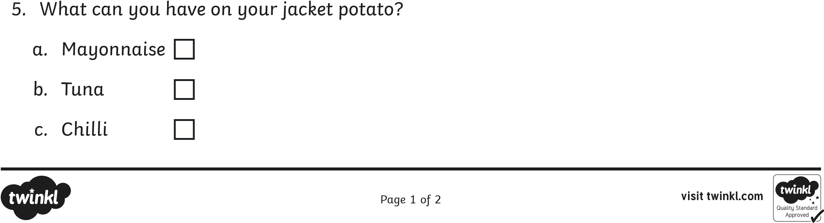
  - Chicken
  - Mushroom
- What can you have a side dish?
  - Jacket potato
  - Chips
  - Soup
- What sandwich filling can you have?
  - Egg
  - Chicken
  - Ham
Going to a Cafe for Lunch
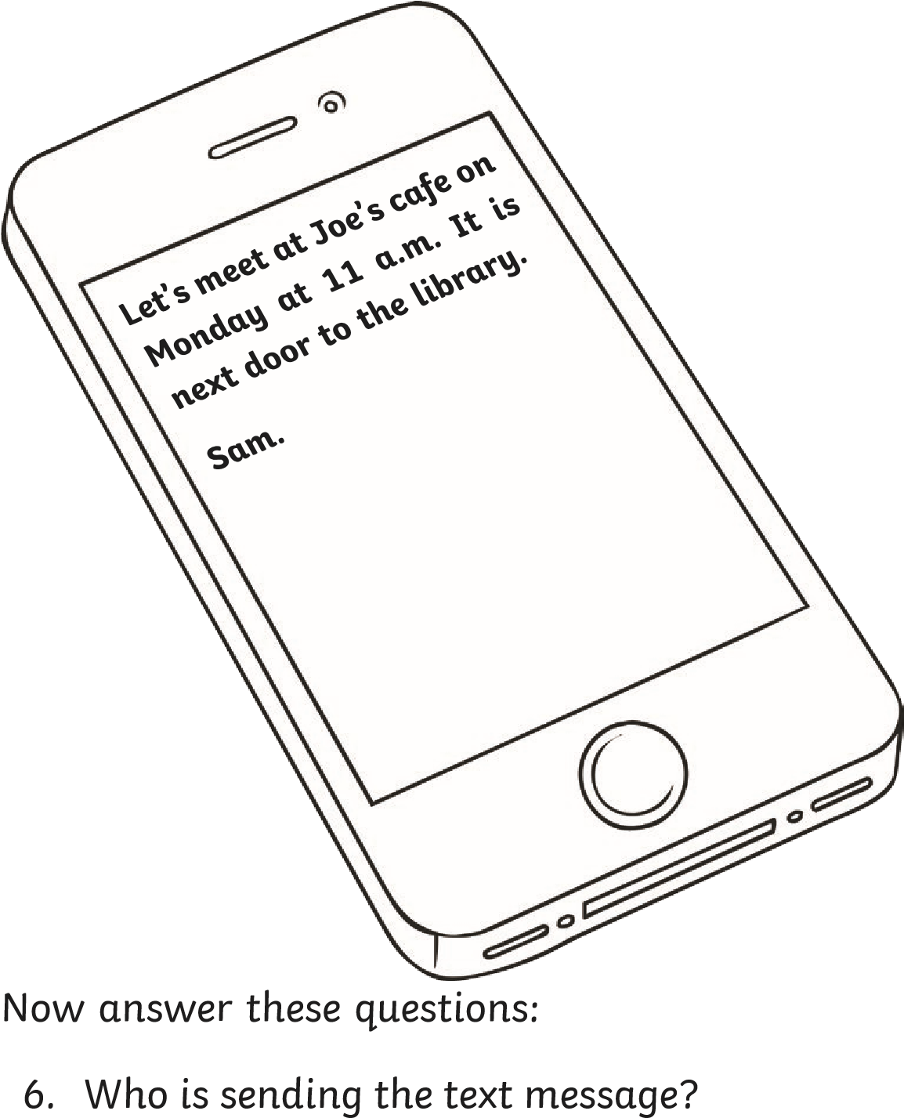

- What day are you going to meet him?

- What time are you going to meet him?

- Where is Joe’s cafe?

