[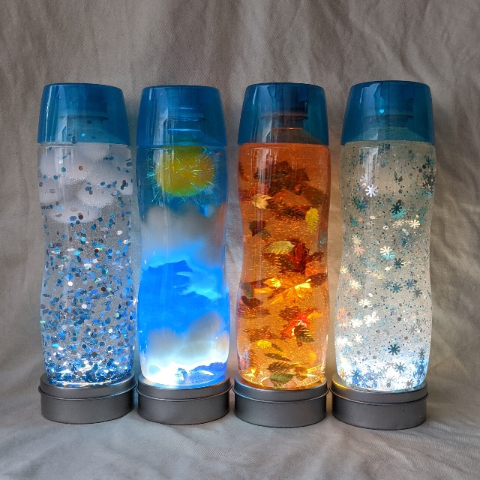](https://www.google.co.uk/url?sa=i&url=https%3A%2F%2Fwww.teainthewild.com%2Fseasons-and-weather-sensory-bottles%2F&psig=AOvVaw1x97B7K24uX_6W3_c4tdsJ&ust=1590796495599000&source=images&cd=vfe&ved=0CAIQjRxqFwoTCNjYhfng1-kCFQAAAAAdAAAAABAJ)

[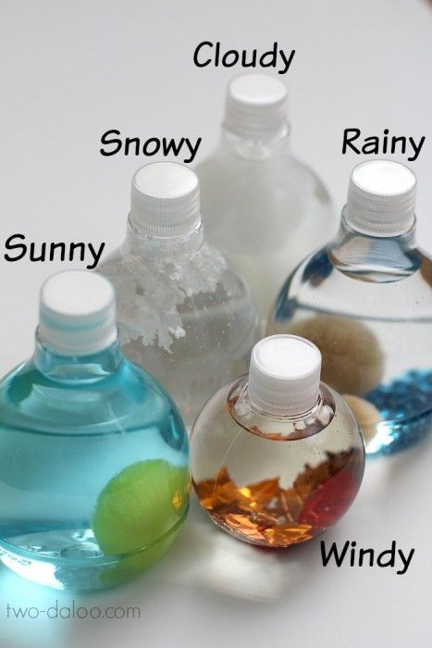](https://www.google.co.uk/url?sa=i&url=https%3A%2F%2Fwww.pinterest.com%2Fpin%2F215680269638106472%2F&psig=AOvVaw1x97B7K24uX_6W3_c4tdsJ&ust=1590796495599000&source=images&cd=vfe&ved=0CAIQjRxqFwoTCNjYhfng1-kCFQAAAAAdAAAAABAP)

[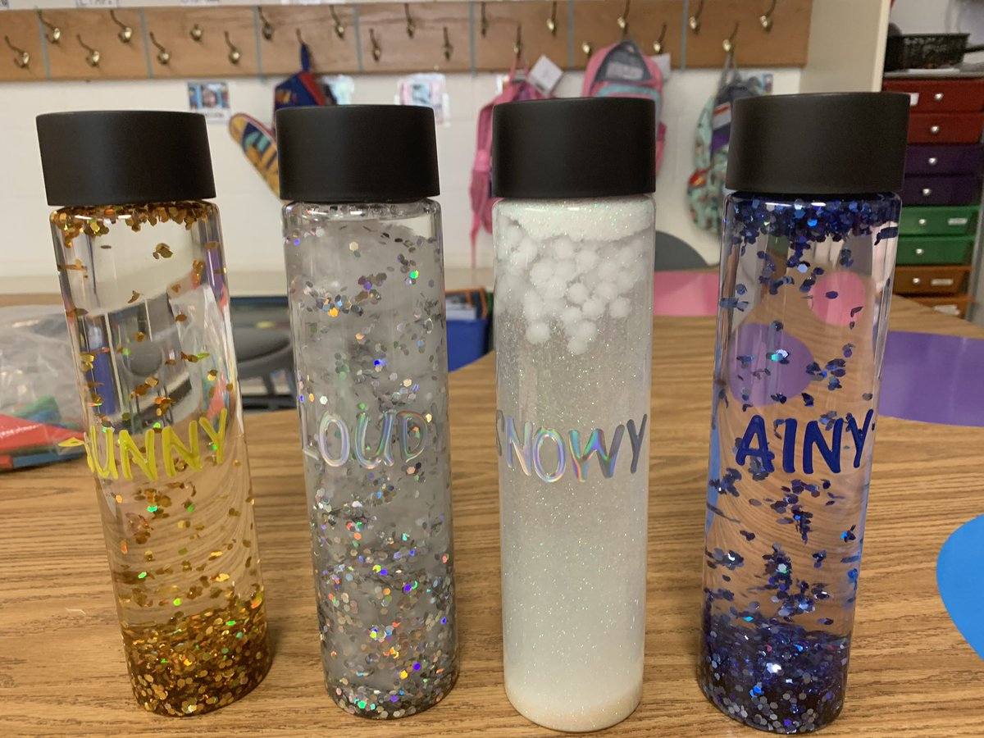](https://www.google.co.uk/url?sa=i&url=https%3A%2F%2Ftwitter.com%2Fats_fcps%2Fstatus%2F1173620376276033536&psig=AOvVaw1x97B7K24uX_6W3_c4tdsJ&ust=1590796495599000&source=images&cd=vfe&ved=0CAIQjRxqFwoTCNjYhfng1-kCFQAAAAAdAAAAABAj)

[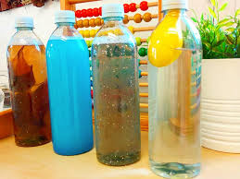](https://www.google.co.uk/url?sa=i&url=https%3A%2F%2Fwww.facebook.com%2Flittleclovers%2Fposts%2F2598354886888325&psig=AOvVaw1x97B7K24uX_6W3_c4tdsJ&ust=1590796495599000&source=images&cd=vfe&ved=0CAIQjRxqFwoTCNjYhfng1-kCFQAAAAAdAAAAABAq)