**Skills for Independence and Employability**

**Managing My Own Money**

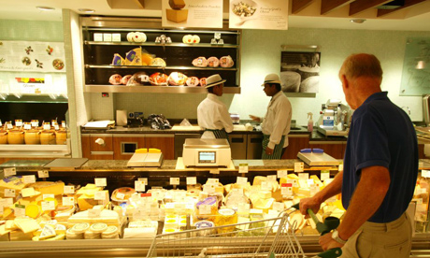

The aim of this booklet is to introduce you to ways of managing your personal finances.

You will be encouraged to prepare a personal budget and to carry out simple transactions.

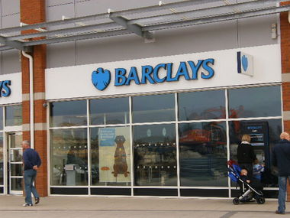

Being in control of your finances is a skill that is essential in living independently, maintaining a home and family or running a business.

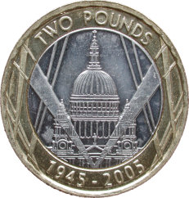

Therefore learning how to manage your money is useful for people at any stage or in any walk of life, especially because of concerns over the growing number of people getting into unmanageable debt.

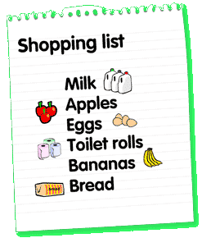**In this booklet you will:**

* Identify your weekly income
* Identify the items you need to spend money on

* Learn how to prepare a simple, weekly budget

* Investigate some of the services banks and building societies offer

* Practise simple calculations when making a purchase.

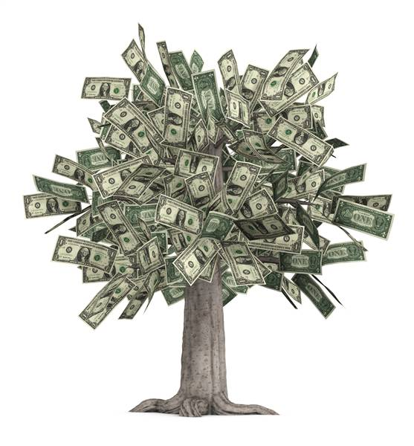**Task 1: What a way to make a living**

Unfortunately, despite many of us wishing it was so, money doesn’t grow on trees.

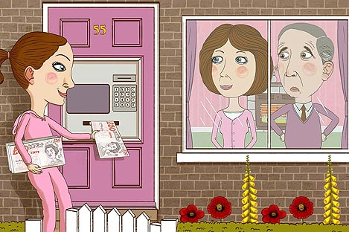

So how do you get your hands on cash each week, have you got a part time job, do household chores or do you get your money from the bank of mum and dad?

1. List 3 different ways that people can make an income each week

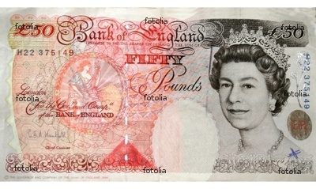

...........................................................................................................................................

...........................................................................................................................................

...........................................................................................................................................

...........................................................................................................................................

2. Now can you identify how you get your income each week?

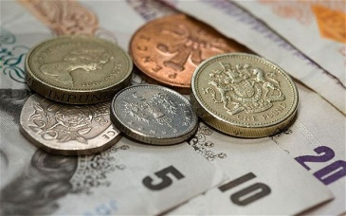

.....................................................................................................................................................

......................................................................................................................................................

......................................................................................................................................................

..................................................................................................................................................

..................................................................................................................................................

3. How much money do you get each week? **£____________**

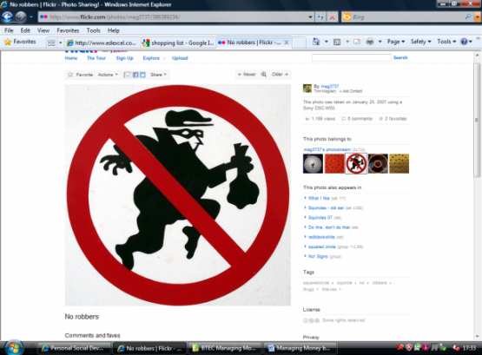

4. Now make a leaflet to show the different ways that you could increase your personal income. *(****Sorry but all ideas must be legal*** *)*

**Task 2: What I spend my money on**

Create a poster showing all the items that you spend your money on each week.

* 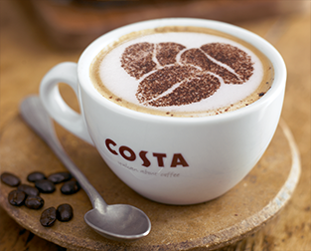Try to include everything from using public

transport, buying food and drink to sweets, magazines and trips out with your friends.



 

* Add an image or drawing to show each item you buy and put the cost next to each picture.
* At the bottom of your poster show the total money you spend each week.

**Task 3: Prepare a simple budget**

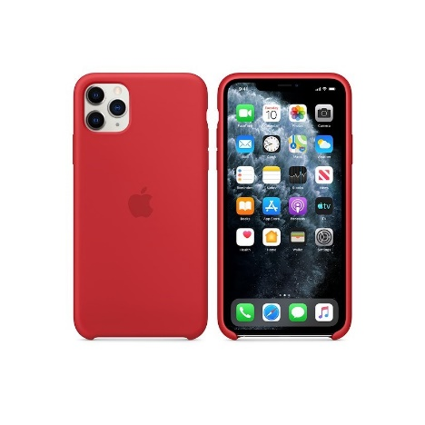

Sometimes we might like to buy something very expensive like a new bicycle, a smart phone, a games console, a computer or a foreign holiday.

Often we cannot afford to pay for these items all in one go.

When we cannot afford to pay for something all at once we can prepare a budget. A budget is when we save up a little money each week or month to go towards something expensive.

**Prepare a budget to help you save up for something expensive**

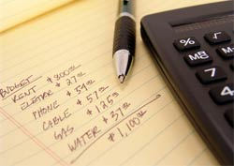1. Identify at least one really expensive item that you would like to buy.

2. Identify the cost of each item you wish to buy.

3. Plan a budget to help you save enough money to buy the item. Include all of the following information:

* How much money you have to spend each week.
* How much money you could save each week towards the item.
* How long it will take to save for the item.
* Ways you could save more money e.g. cutting the amount you spend, doing extra household chores, getting a part time job etc.

**Task 4: Investigating banks and building societies**

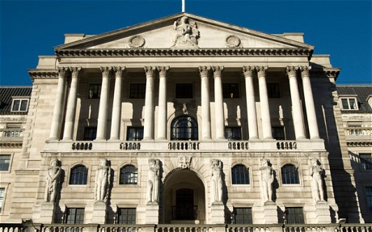When we are saving up to buy something really expensive we can put money away each week into a bank or a building society.

*(The Bank of England, where decisions to raise or lower interest rates are made each month)*

1. Make a list of banks and building societies found in your local area.

………………………………………………………………………………………………………………………………

………………………………………………………………………………………………………………………………

………………………………………………………………………………………………………………………………

………………………………………………………………………………………………………………………………

………………………………………………………………………………………………………………………………

………………………………………………………………………………………………………………………………

………………………………………………………………………………………………………………………………

………………………………………………………………………………………………………………………………

2. Research and draw or copy the logos of the banks and building societies that you have identified.

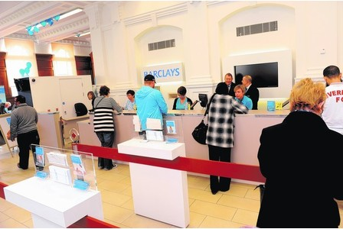3. Identify some services offered by banks and building societies. ………………………………………………………………………………………………………………………………

………………………………………………………………………………………………………………………………

………………………………………………………………………………………………………………………………

………………………………………………………………………………………………………………………………

………………………………………………………………………………………………………………………………

………………………………………………………………………………………………………………………………

………………………………………………………………………………………………………………………………

………………………………………………………………………………………………………………………………

4. Choose one bank from your list and find the following information

|  |  |  |
| --- | --- | --- |
| **Current Savings Rate** | **Current Mortgage rate** | **Planned overdraft fee** |
|  |  |  |
|  |  |  |

**Task 5: Select items to purchase for Ifield Fun Day BBQ**

We are visiting Morrison’s on to buy items for the Ifield Fun Day BBQ.

**20 pork sausages 500ml orange squash**

**10 Beef burgers 500ml of lemon squash**

**200g Cheese 50 disposable plastic cups**

**20 bread rolls 20 jam doughnuts**

**10 seeded burger baps 24 Bakewell tarts**

**10 Quorn sausages 24 scones**

**200g bottle of ketchup 500g Flora light margarine**

**200g bottle of brown sauce 200 paper serviettes**

1. Which **two** items from the shopping list will you buy?

Write them down in the table below.

|  |  |
| --- | --- |
| **My shopping list** | **Quantity/ weight** |
|  |  |
|  |  |

2. Find images of the two items that you have chosen. Print off or draw the images of the two items and stick them on to the page below.

|  |  |
| --- | --- |
|  |  |

**Task 6: Practise estimating the cost of my shopping**

A good skill to have when shopping is to be able to estimate the total cost of items before you get to the till.

1. Choose any two items from the list below and make a rough estimate of the price. Write down your estimate.
2. Use a calculator to check your estimate.
3. Choose different pairs of items from the list below and write down your estimates.

|  |  |  |  |
| --- | --- | --- | --- |
| http://newsimg.bbc.co.uk/media/images/44095000/jpg/_44095017_hovis_other_203.jpg | http://www.penis-enlargement-exposed.com/images/banana.jpg | http://coolaggregator.files.wordpress.com/2008/06/070815_coke_vmed_11awidec.jpg | http://www.asaltandbattery.com/assets/images/products/copies/lg_pg-tips.jpg |
| **£1.19** | **35p** | **65p** | **£2.55** |

|  |  |  |  |
| --- | --- | --- | --- |
| http://img.tesco.com/Groceries/pi/024/5000119004024/IDShot_225x225.jpg | http://www.howbigismypotato.com/potato.jpg | https://www.cookingplanit.com/public/uploads/inventory/chicken_breast__1332428869.jpg | http://kellys-expat-shopping.nl/files/2013/06/tate-lyle-caster.jpg |
| **95p** | **82p** | **£2.49** | **£1.85** |

|  |  |  |  |
| --- | --- | --- | --- |
| http://photo.elsoar.com/wp-content/images/Two-eggs-Picture-A.jpg | http://www.refreshmentshop.co.uk/images/crisps_and_snacks/walkers-cheese-onion.jpg | http://img.kiosko.net/2015/07/16/uk/i_paper.200.jpg | http://www.chaucersolutions.co.uk/images/products/radox-hand-soap-dispenser-pack-bkk7.jpg |
| **£1.35** | **55p** | **40p** | **87p** |

|  |  |  |  |
| --- | --- | --- | --- |
| https://s-media-cache-ak0.pinimg.com/236x/96/e3/d3/96e3d3e12e9c0473a5456cc6617b605c.jpg | http://www.picpedia.co.uk/images/r/red-pepper.jpg | http://www.colgateprofessional.com/Professional/v1/en/us/locale-assets/img/thumbnails/Products-Detail-360Toothbrush-Thumb.png | http://www.limoncello.co.uk/acatalog/giagpureetube.jpg |
| **£1.35** | **72p** | **95p** | **49p** |