The Frog Olympics
LO – to know the story of The Frog Olympics
I can:
- Listen to the story.
- Point out key objects and characters from the story.

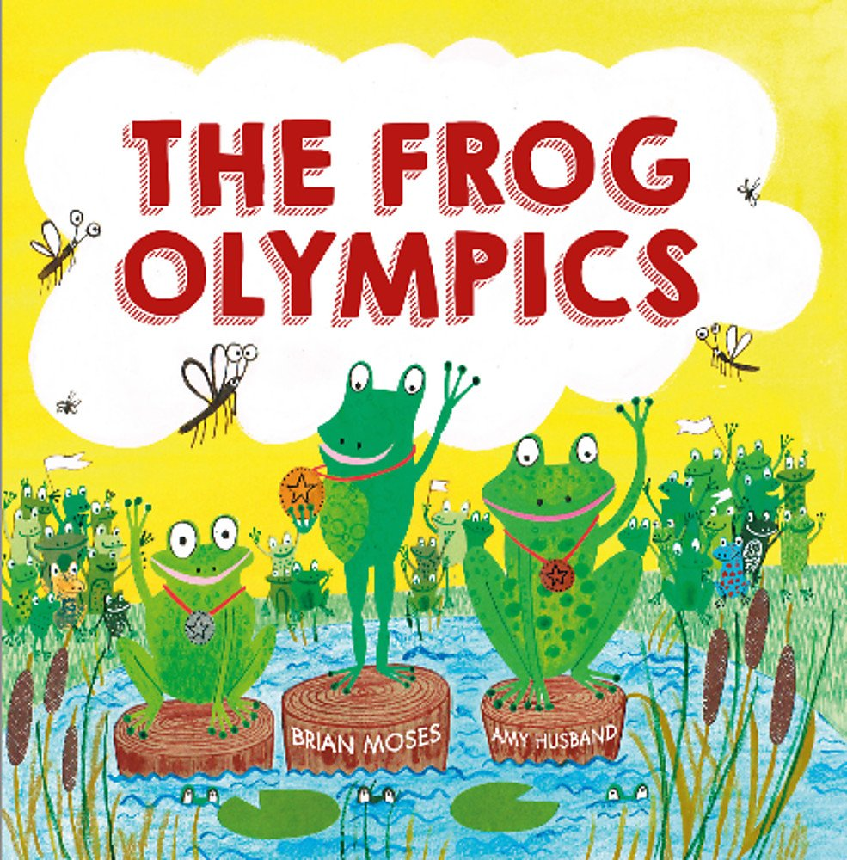

Comments:

