The Frog Olympics
LO – to know the story of The Frog Olympics
I can:
- Listen to the story.
- Answer literal questions about the story.

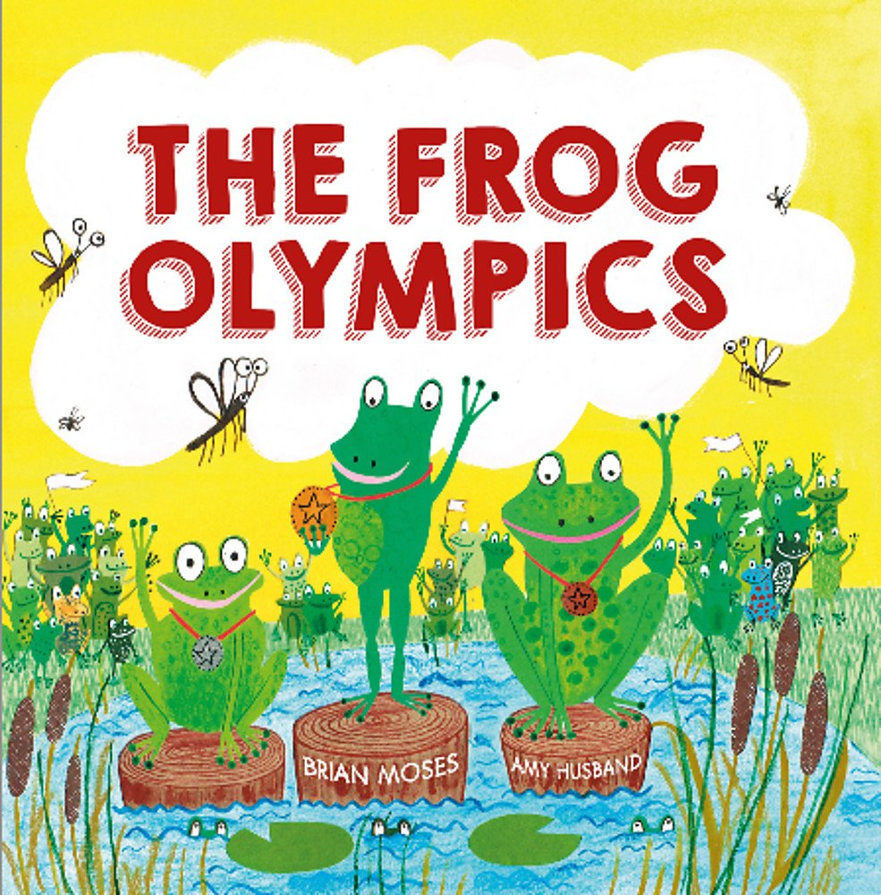

Comments:

