LO – to name different sports.
I can:
- Name the sport.
- Over-write the words forming recognisable letters.


F i s h i n g


B a s k e t b a l l

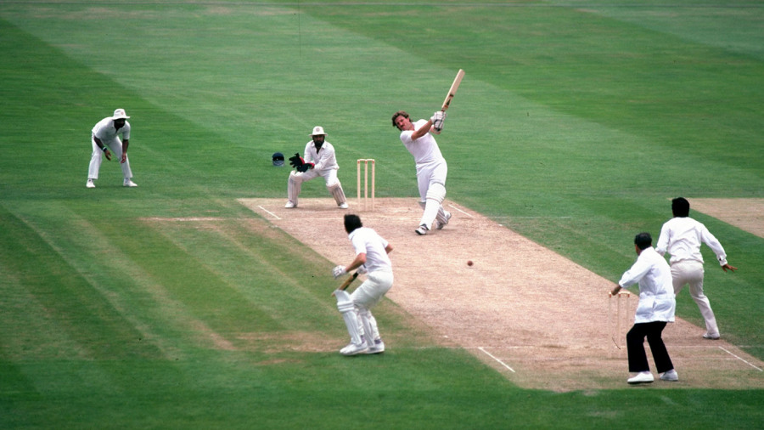
C r i c k e t
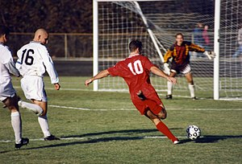

F o o t b a l l

