Doing
the
Laundry
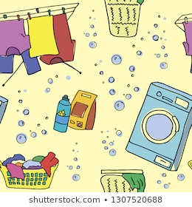

Doing the Laundry
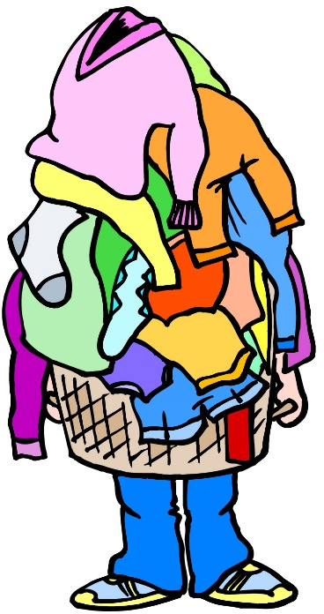
Okay, you need clean clothes. You also do not want to spend your “life” doing the laundry. So, let us learn how to get this job done as quickly, easily and as well as possible.
The steps to doing laundry are:
1. Sorting: A red shirt in with your white undies will result in pink underwear. So, separating your loads will save you time and money in the long run.
2. Washing: Most clothes can go in the washer in cold, warm or hot water. Some items need to be hand-washed; some need to be dry-cleaned. Look at the label when you buy a new piece of clothing if you do not want the extra work.
3. Drying: Most machine-washable clothes can be thrown into a tumble dryer. Dryer settings range from “delicate” to “heavy-duty.” Some clothes need to be hung to drip-dry; others need to be laid flat. Again, read the labels when you buy.
4. Folding: If you grab your clothes as soon as the tumble dryer stops and fold them up, you usually can skip the next step.
5. Ironing: Some clothes need to be ironed no matter what you do. Others look fine if you do not let them wrinkle in the tumble dryer or on your bedroom floor.
6. Putting Away: Folded clothes can still look messy if you leave them in a pile on your floor. Take a minute - put them away.

Doing the Laundry

Answer the following questions:

1. What are the 6 steps to laundry?
a. Piling up, Ignoring, Ignoring, Hiding, Ignore some more, Begging Mum to do it.
b. Sorting, Washing, Drying, Folding, Ironing, Putting Away.
c. Putting Away, Piling, Hiding, Smelling, Washing, Hanging.

2. Why is it important to fold clothes as soon as the tumble dryer stops?
a. So the clothes do not begin to wrinkle.
b. So they feel nice and warm when you fold them.
c. It is not important.

3. Why should you look at a label when you’re buying new clothes?
a. To see what country made the clothes.
b. To see if cleaning instructions are difficult or expensive.
c. To see what the inside of the clothes looks like.

4. Why should you sort?
a. So colours do not run and ruin your clothes.
b. So your clothes will last longer and look nicer.
c. Both answers are correct.

Getting Organised for Laundry Day



To organise your laundry you will need:

1. A Basket: Put your dirty clothes in a laundry bin or basket. Keep it in the bathroom or in your bedroom - close to where you take off your clothes.

2. A Small Basket: Empty your pockets WHILE YOU TAKE YOUR CLOTHES OFF. Let your wallet, mobile phone, ear phones, bus pass and keys “live” in the basket and you will always know where to find them.

3. A Cup: Put the change from your pocket into the cup. Then it won’t end up in the washing machine or tumble dryer AND you might even use it as part of your monthly savings.

4. A Stain Remover Bar or Spray: You will remember to treat that nasty coffee/cola stain on your T-shirt if you take care of it as soon as you take your shirt off. Always refer to the manufacturer’s instructions if you intend to leave the item of clothing until laundry day to be washed. Some stain removing products require the clothing to be washed within a set time period.

Getting Organised for Laundry Day Worksheet

Answer the following questions:

1. Name 2 reasons to have a small basket next to your dirty clothes basket:

- ………………………………………………………………………………………………………………

- ………………………………………………………………………………………………………………

2. Where would you put the dirty clothes basket in your house?

……………………………………………………………………………………………………………………….

3. Why would you put a cup next to your dirty clothes basket?

……………………………………………………………………………………………………………………….

4. What do you need to read carefully before using a stain remover bar or spray?

…………………………………………………………………………………………………………………………
Sorting – The Basics

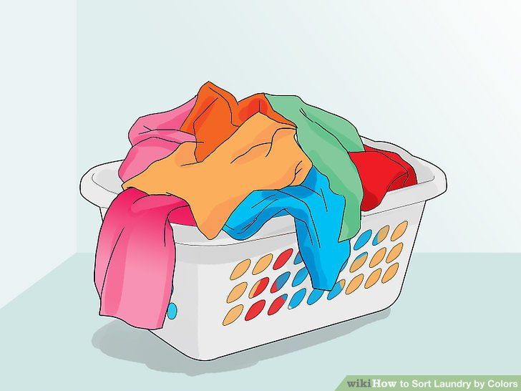

Sort clothes into 3 piles:

1. Whites: Socks, panties, briefs, vests, tea towels, T-shirts…anything that is all white or mostly white. If your white T-shirt has a brightly coloured cartoon on the front, put it in “light coloured” clothes so your picture does not fade.

2. Towels and Linens: This is all that big, bulky stuff that comes off your bed – sheets, Duvet covers, pillowcases, blankets and your towels and flannels.
Keep it separate from everything else because it makes a lot of lint that can be hard to get off your jeans or sweaters.

3. Coloured Clothes: This is everything else. If you have a lot, you can separate it into “light” coloured clothes (pastel shades) and “dark” coloured clothes (black, brown, red, navy, dark green etc).

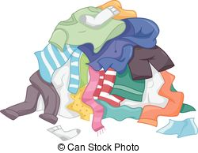
Sorting - Special Clothes

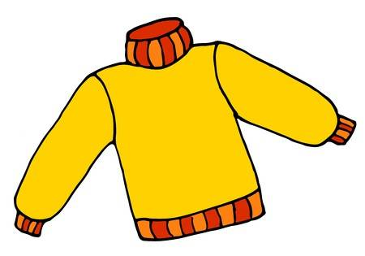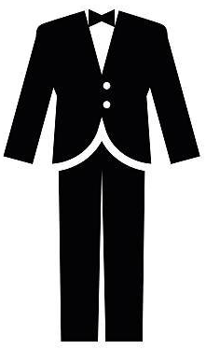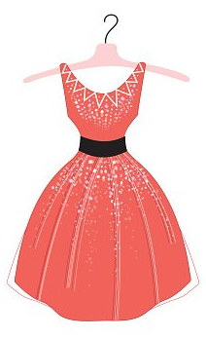

Some clothes cannot be washed in a washing machine, so you must read the labels carefully.

“Care labels” are sewn into the neck or side seams of clothes most of the time. Find the care label and read it BEFORE you buy clothes.

Special Clothes usually need to be cared for in one of two ways:

1. Dry Clean Only. This means you must take the clothing to a dry cleaning shop and let them clean it for you. It will cost between £5 and £15 to dry clean a piece of clothing or a suit.

2. Hand Wash. This means you must use a special Hand Washing detergent for delicate fabrics. You can wash the item of clothing in a sink by rubbing the cloth together, then rinsing it in running water and wringing it out GENTLY by hand. Usually these clothing items must then be hung to dry or laid flat to dry.

Sorting Clothes Worksheet

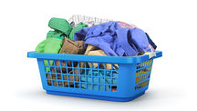

Match the item to the correct load:

a. Towels and Linens b. Coloured Clothes

c. Dry Clean Only d. Hand Wash e. Whites

1. Red underwear 2. White socks

3. Bed sheets/Duvet cover 4. “Dry clean only” trousers

5. White and pastel pink striped shirt 6. Blue jeans

7. Patterned Boxer shorts 8. White cotton vests

9. Green bath towel 10. A stained white T-shirt

11. Hand-washable silk tie 12. Pillowcases

The Washing Machine

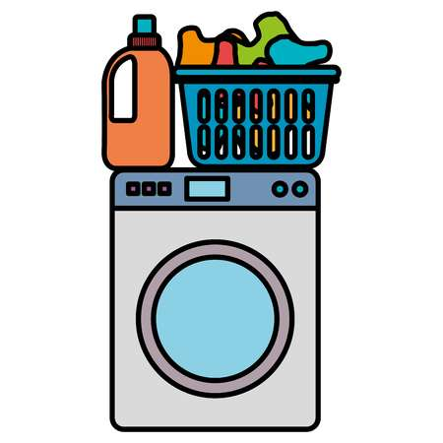

There are two kinds of washing machines: Front loading and Top loading.
The names just tell you where you put the clothes into the machine.
Front loaders use less water and less detergent. Other than that, they are very much the same.

When you use a washing machine, you need to think carefully about the following 3 things:

1. The size of the load you want to wash.

2. The temperature of your water.

3. The length and strength of the wash cycle.

No matter how many other dials or buttons on your machine, these are the only three things you really need to decide on before you begin your laundry.

The Washing Machine - Load Size

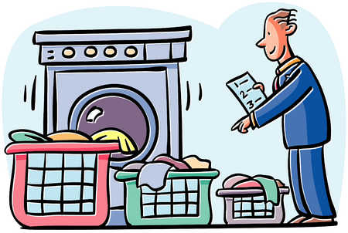

No matter what words they use, washing machines usually have about three load sizes: large, medium and small.

Loads should really be measured by weight and many washing machines do this automatically when the clothes are placed inside the drum of the machine.
You may need to refer to the instruction manual for your washing machine.

Generally, the load to be washed should look like this when placed in the drum of the machine:

1. A Large load: Fills about 2/3 of the washing machine drum.

2. A Medium load: Fills about 1/2 of the washing machine drum.

3. A Small load: Fills about 1/3 of the washing machine drum.

DO NOT OVERFILL - The washing machine needs room for the water and for the load to move around in the drum to clean the clothes properly.

The Washing Machine - Load Temperature

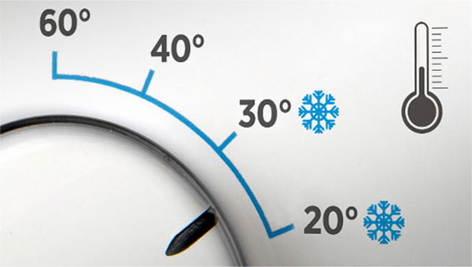

Remember the sorting rules?

The next step is sorting out the correct temperature for your washing load.

1. Whites: VERY HOT or HOT. Whites usually sit next to your body and can get sweaty and smelly. The very hot water kills most bacteria and sanitises the items.

2. Towels and Linens: HOT or WARM. Like whites, these items pick up germs from being right next to your body. The hot or warm water sanitises them.

3. Coloured clothes: WARM or COLD. Warm or cold water helps these clothes keep their colours so they do not fade and the colours do not run into each other. It also keeps them from shrinking.


The Washing Machine - Length and Strength of the Cycle

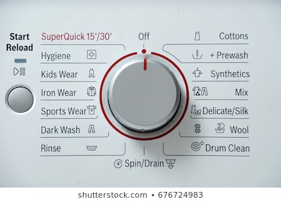

The basic rule is, the tougher the fabric eg Cotton Denim, the longer and harder it can be washed. The more delicate the fabric eg Lace, the shorter the time it can be washed and the more gently it needs to be treated.

1. Whites: They are made of sturdy cotton or a cotton and polyester blend. Either way - they are strong and they get dirty.

a. If the items are REALLY dirty use the pre-wash or the wash plus programme which most of today’s washing machine have.
b. “Reduced Ironing” cycles usually end in cold water so clothes do not wrinkle so much.
c. The “Cottons” cycle on your washing machine assumes that your fabric is both strong and dirty.

2. Towels and Linens: Wash these items on the “Cottons” cycle.
They are strong and sturdy fabrics.

3. Coloured Clothes: “Normal” or “Easy Care” cycles work well for these fabrics.

4. Delicates: Lace material; delicate, light material; clothes with beads or sequins all need a gentle touch. “Delicates” is a short, gentle wash.

The Washing Machine Worksheet

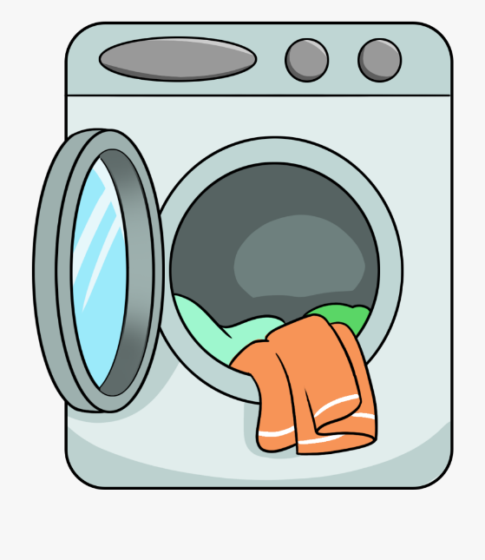
Circle your answers:

1. No matter how plain or fancy the dials and buttons on your washing machine, what decisions do you need to make before you load the machine?
a. Load temperature, time and total.
b. Load size, temperature, and length/strength.
c. Load agitation, agility and angle.

2. White clothes are best washed in what temperature water?
a. Cold
b. Warm
c. Hot

3. Delicate fabrics do best on what cycle?
a. Delicate cycle
b. Cotton cycle
c. Normal cycle

4. A large load of clothes fills how much of the washing machine drum?
a. 1/3 of the drum
b. 2/3 of the drum
c. The whole drum

How to use the Washing Machine

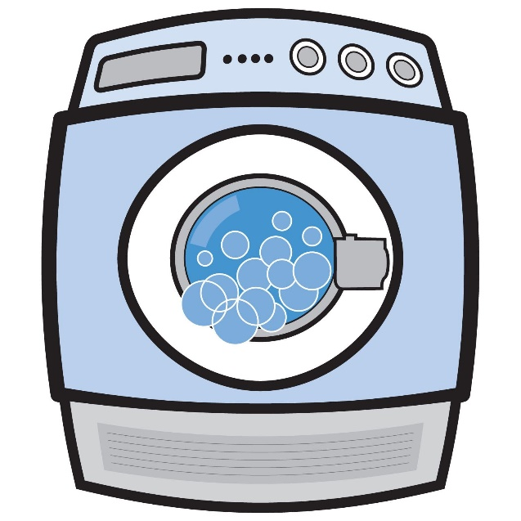

1. Set the dials – choose:
a) The load size
b) The temperature
c) The strength and length of the cycle

2. Feed the machine: You will need to add the washing agent to the machine as directed in the instruction manual, depending on which laundry detergent you choose eg a loose powder, tablets or a liquid detergent.
Always use the correct amount of washing detergent as recommended by the manufacturer.

3. Add the extras: If you are using a laundry fabric softener, add it to the washing machine’s dispenser now.

4. Load the clothes: Loosely place the clothes into the drum. This also gives you one last chance to squeeze the pockets and make sure your wallet, phone or pens etc have been removed.

5. Close the door: Wash cycles take between 20 minutes to an hour depending on the cycle and pre-wash times.

The Tumble Dryer - The Basics

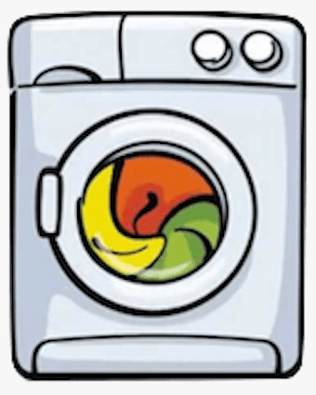

When you tumble dry clothes, you really only need to consider two things:

1. How hot?
2. How long for?

Heat: Tumble dryers usually dry with three basic temperatures.
Look at your clothes and use these rules to decide what heat setting to use.
These temperatures are:

a. Cool air only - for delicate clothing that will shrink with heat.
b. Medium heat - for permanent press clothes and lighter weight fabrics.
c. High heat - for towels, sheets and heavy cotton fabrics.

Time: Some Tumble dryers will decide the time for you if you choose settings like “permanent press” or you can choose the time yourself - usually from about 15-60 minutes.

The Tumble Dryer - Lint Traps

As the tumble dryer dries your clothes lint (soft fluff) comes off the fabric.
The lint collects in a lint trap or filter and it is very important to clean the trap before you use the tumble dryer and after you finished drying your clothes.

If you do not clean the lint trap, your clothes will take “forever” to dry, wasting energy and money.

A build-up of unremoved lint could also cause a possible fire risk.

Lint traps are usually found in two places: on top of the tumble dryer or in front of the tumble dryer’s drum, like this:

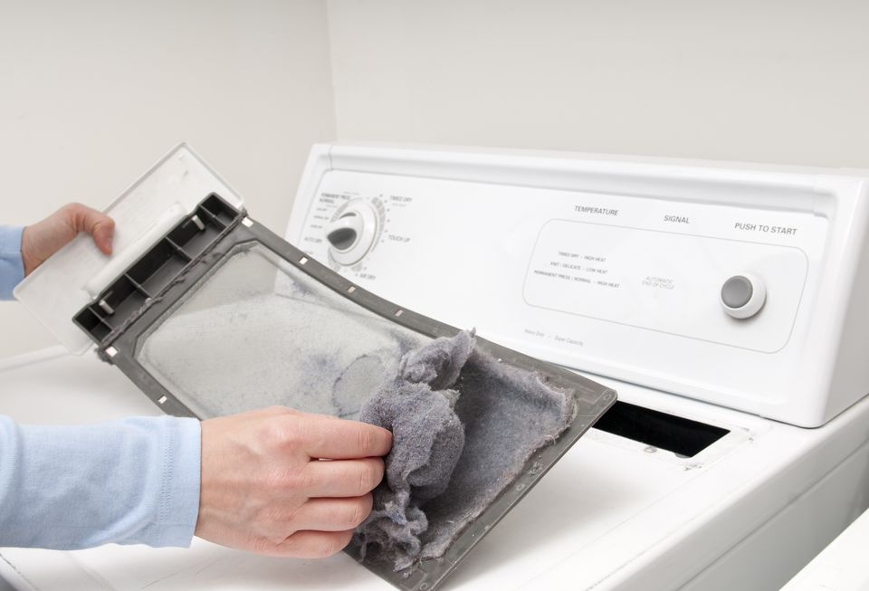

On top of the Tumble Dryer

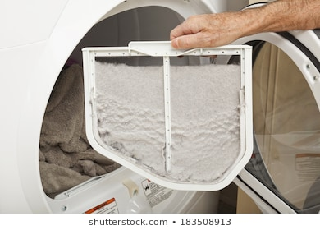

In front of the Tumble Dryer’s drum

The Condenser Tumble Dryer

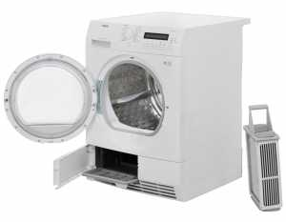

A Condenser tumble dryer works slightly differently by condensing the warm air from the wet clothes into water.

Once the air condenses into water, it is channelled into the reservoir or condenser box situated at the bottom or at the top of the tumble dryer.

The box of condensed water will need to be emptied regularly and usually an indicator on the tumble dryer will “bleep” to remind you.

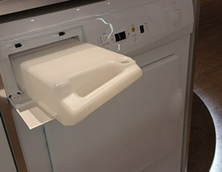
How to use the Tumble Dryer

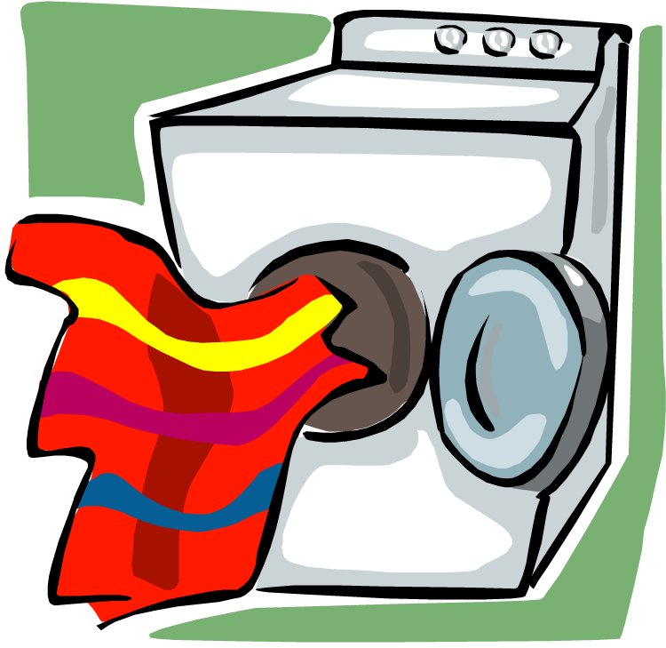

Here are the steps to tumble drying your clothes:

1. Check the lint trap or filter and clean if necessary.

2. Open the dryer and load your laundry.

3. You may add a dryer sheet if you want. The sheets add a fragranced fabric softener to your clothes so they’re not scratchy and they keep the lint from sticking to your clothes.
They also remove “static cling”- the static electricity that makes clothes stick to your body and cause shocks.

4. Close the door, making sure no clothing is trapped in the door.

5. Choose your heat and time settings, depending on the clothes you are drying.

6. Make note of the ending time. Plan to be back to the tumble dryer before the end time to check if the clothes are dry and so the clothes do not have time to wrinkle.

7. Clean the lint trap thoroughly, removing all the fluff and replace the trap or check to see if the condenser box needs emptying.

The Tumble Dryer Worksheet

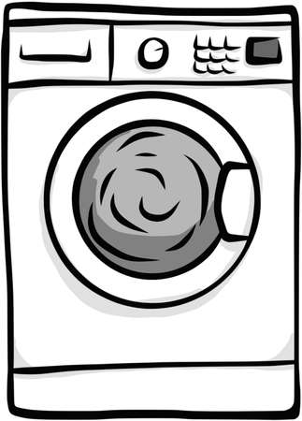
Circle your answers:

1. Why should you clean out the lint trap regularly?
a. It saves energy and money by letting clothes dry faster.
b. It is not necessary.
c. It prevents a fire risk.
d. Both a and c are correct.

2. What does adding a dryer sheet to the tumble dryer do for my clothes?
a. It keeps clothes from feeling scratchy.
b. It keeps clothes from having static cling.
c. It does both a and b.
d. It does neither a nor b.

3. I should be close to the dryer when it ends:
a. So clothes do not have a chance to wrinkle.
b. So I can hear the buzzer up close.
c. So I can touch the clothes while they are warm.

4. Lint traps or filters are usually found:
a. Behind the tumble dryer.
b. On top of the tumble dryer or inside the front of the tumble dryer’s drum.
c. Tumble dryers do not have lint traps.

