Budgeting

You are having some friends around for dinner and have £20 to spend.
You need to buy all the items on the list below.
Make sure you look at different supermarkets to make sure you are getting the best deal.
Some supermarkets you might want to try are Asda, Sainsburys, Lidl, Morrisons and Waitrose.

Shopping List Best Price

1 x Whole chicken

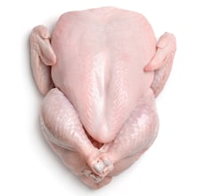

2 x Lemons



1 x bag Carrots
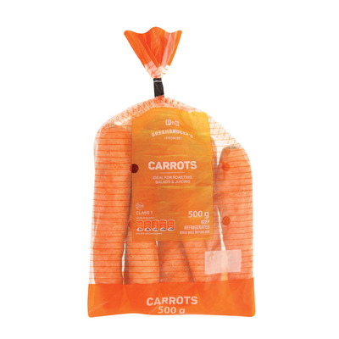

1 x bag Potatoes
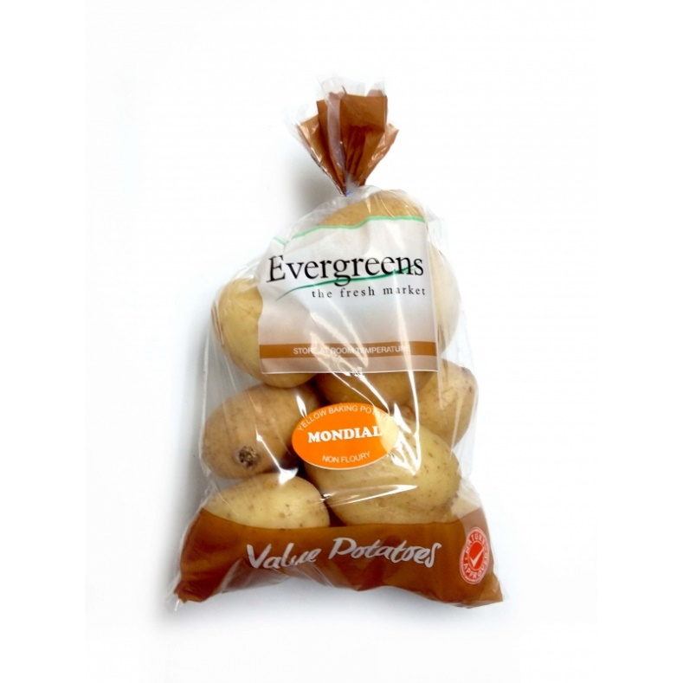

1 x packet Bisto Chicken gravy

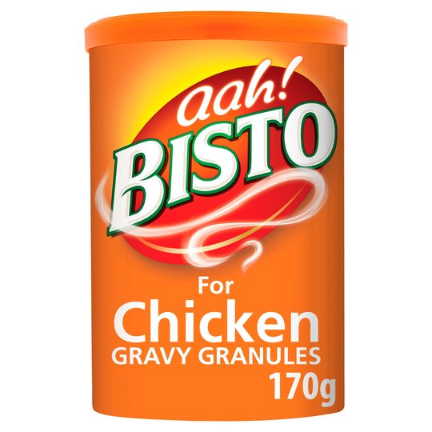

1 x tub Vanilla ice-cream


Total _______________________

You can also use these price-comparison websites to help you compare prices and decide on the best deal.

www.comparesupermarketprices.co.uk

www.mysupermarket.co.uk

You can use this sheet to make notes of the different prices.

Food | Asda | Lidl | Waitrose | Morrisons | Sainsburys
1 x Whole chicken
2 x Lemons
1 x bag Carrots
1 x bag Potatoes
1 x packet Bisto Chicken gravy
1 x tub Vanilla
Ice-cream

Did you find any deals? …………………………………………………………………...
………………………………………………………………........................................................................................

Which supermarket was the cheapest?
…………………………………………………………………...…………………………………………………………………...

Which supermarket was the most expensive?
…………………………………………………………………..…………………………………………………………............

