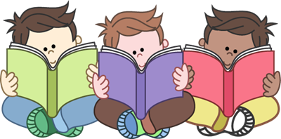
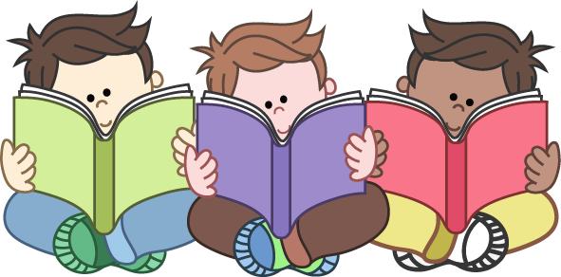
Daily reading

You can read or share any story book that you have at home.
Ask questions about what you have read. Ask your child to point to the characters and objects to check their understanding.
Who is in the story?
What happened?
What do you think will happen next?
Why did they say/think that?
What is your favourite part of the story?
What can you see in the picture?
Can you re-tell the story?
What new and interesting word can you find? What does it mean?
Please also see the recommended reading book list. Books are available online, but you will all have lots to read at home so don’t feel you have to spend any money.



