Claude Monet Water Lilies Art Project for Kids: Tutorial
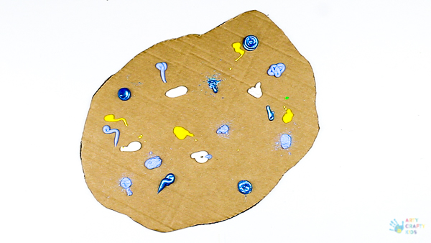
Step 1: Using a piece of cardboard, cut it into a pond like shape and add sporadically add blobs of blue, yellow and white paint across the surface.
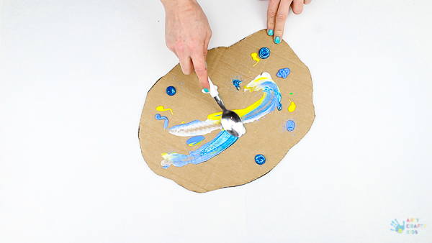
Step 2: Spread the spoon across the surface, capturing the paint and blending, while spreading to across the surface.
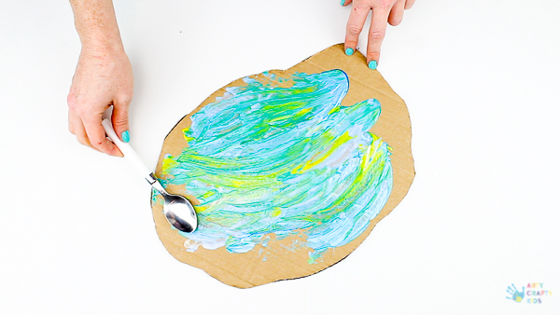
Step 3: Swirl and move the paint across until the cardboard is completely covered.
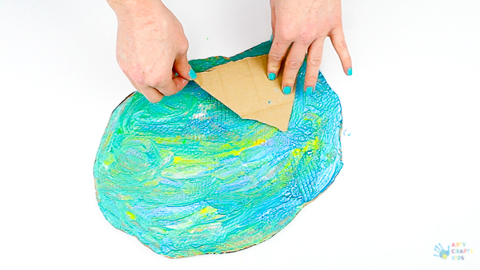
Step 4: To add texture to smooth surface, try tearing the top layer of the cardboard to reveal the corrugated card to create prints across the ‘pond’.
My daughter suggested that these could be ripples created by bugs that often hover across the water, or perhaps a frog that’s just leaped in.
Either way, encourage the Arty Crafty Kids to spend time working on their pond surface, blending colours and if necessary, adding more paint.
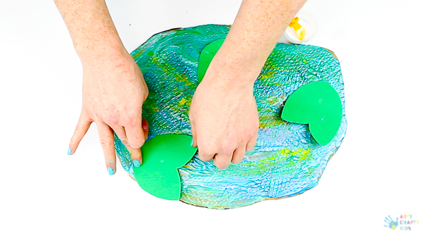
Step 5: Using green stock card, add some lily pads to the pond.
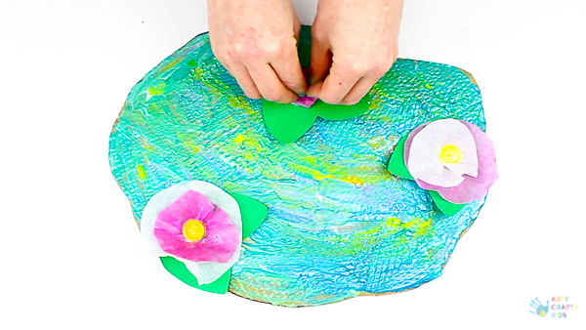
Step 6: And finishing off with tissue paper lilies!
To make the lilies, cut out a pair of circles using two different colours for contrast (or the same) and place a button into the centre, securing with PVA glue.
Then simply scrunch the paper around the button to create a 3D effect.

