Week 2 English

A Midsummer Night’s Dream – English Literature scheme of work
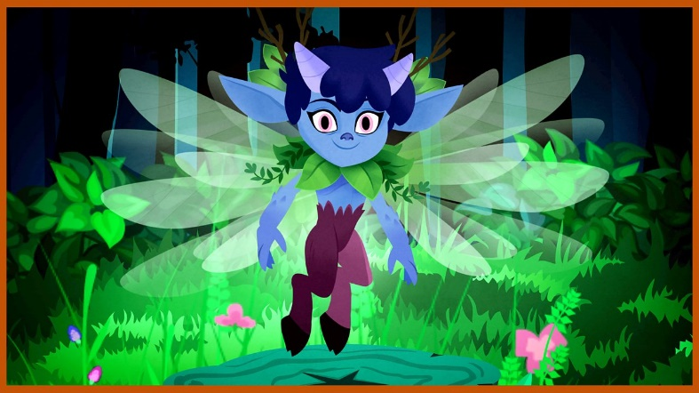
Watch the
play here
online:

https://www.bbc.co.uk/teach/class-clips-video/english-a-midsummer-nights-dream-index/z6rcgwx

Complete the sequencing activity.
http://teach.files.bbci.co.uk/schoolradio/english/a_midsummer_nights_dream/sequencing_activity.pdf

Write a brief description of the mechanicals, you only need to write a couple of sentences for each character. Pick your favourite characters to write about. Who do you find funny?
http://teach.files.bbci.co.uk/schoolradio/english/a_midsummer_nights_dream/describe_the_mechanicals.pdf

Watch this clip, it will explain the story and you can see some live action sequences of a production of A Midsummer Night’s Dream a the Globe Theatre in London.

https://www.bbc.co.uk/teach/class-clips-video/english-ks2-introducing-a-midsummer-nights-dream/zrd9wty

Here is another interesting clip about William Shakespeare his life and times. Now write a report about who he was, when and where he lived, what he did and why we are still learning about him today. If you want to carry out your own research that would be fantastic you can add it to your report. Remember write it in your own words don’t cut and paste!

https://www.bbc.co.uk/teach/class-clips-video/english-ks2-introducing-shakespeare/zfr3cqt

