Lo – to know the story of Room on the Broom.
I can:
- Look at the pictures.
- Write the words to go with the pictures.

 _______________
 ________________

- ________________

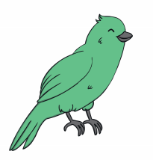 _______________
 ______________
 _________________
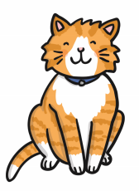 _______________
 ________________
 _________________
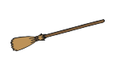
___________________

broom | hat | cauldron | cat | dog
bow | bird | dragon | wand | witch

