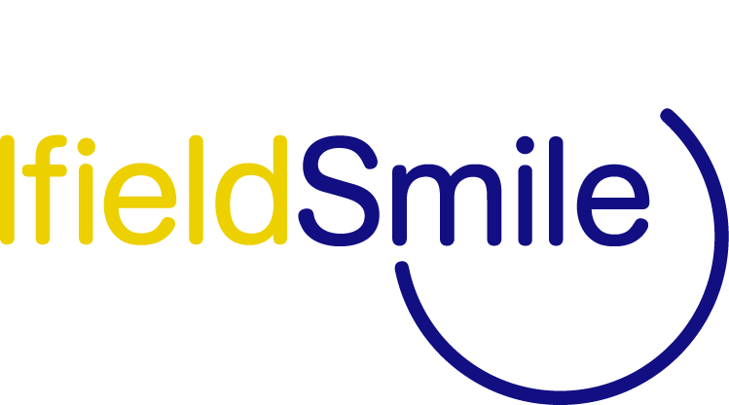
BESPOKE TRAINING REQUEST FORM

Training Title: (Please describe the type of training required)

Name of School/Setting:

Preferred Dates (please list as many as possible):

Preferred Length of Training (AM/PM/All day/Twilight):

Number of Delegates (approx):
TA/Teacher/Both:

Contact Name, telephone, email address:

Any other relevant information:

Bespoke Training Core Charges:

Maintained Schools/Academies - £100 per hour
Early Years Settings - £50 per hour

Please return this completed form to Ifield Smile by:

Email: smile@ifield.kent.sch.uk Telephone 01474 536924.

